EXPERIMENT – 05

MARK SHEET PROCESSING SYSTEM

Aim
To design and deploy a Mark Sheet Processing System on Zoho Creator to demonstrate Software as a Service (SaaS), where student marks are stored, processed, and results such as Average, Percentage, Rank, and Overall Performance are calculated automatically.

Procedure
- Step 1: Login to Zoho Creator using your Zoho account.
- Step 2: Create a new application named 'Mark Sheet Processing System'.
- Step 3: Create a form with fields: Student Name, Register Number, Subject 1–5, Marks 1–5, Average, Percentage, Rank, Overall Performance.
- Step 4: Create workflows to calculate Average, Percentage, Rank and Overall Performance.
- Step 5: Create a report to display all student mark sheets.

Suggested Workflow Logic
Average = (Marks1 + Marks2 + Marks3 + Marks4 + Marks5) / 5
Percentage = (Total Marks / 500) × 100
Rank = Based on Percentage
Overall Performance = A+, A, B+, B, C according to percentage.

Application Preview

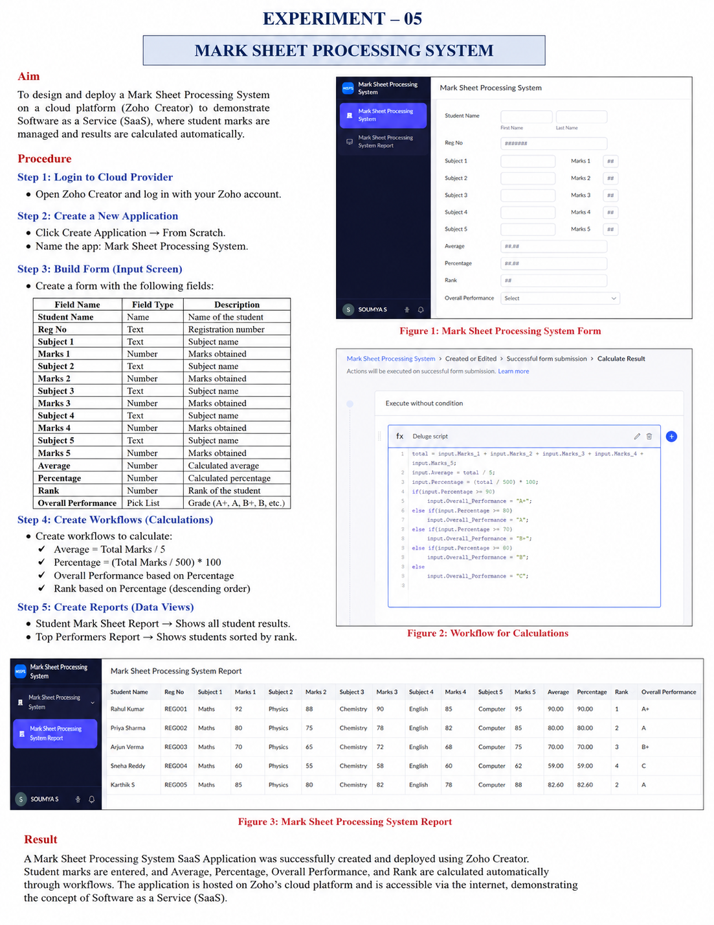
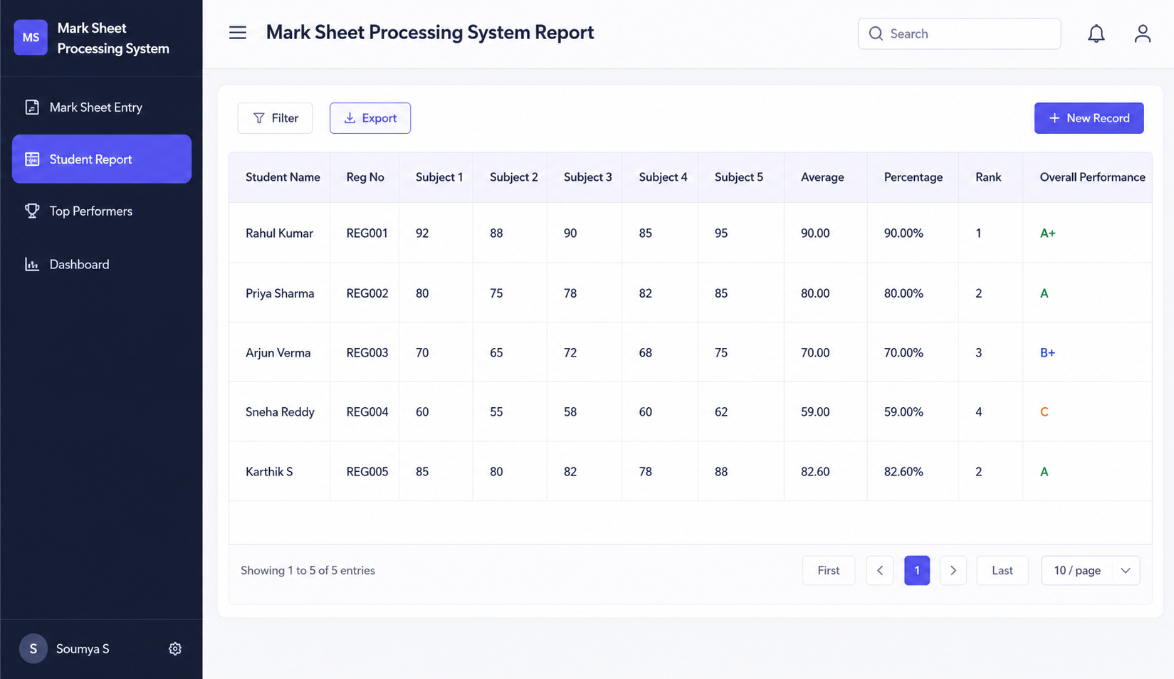
Figure 1: Sample Mark Sheet Processing System

Result
A cloud-based Mark Sheet Processing System was successfully designed using Zoho Creator. The application stores student information, calculates Average, Percentage, Rank, and Overall Performance automatically, and generates reports online, demonstrating the SaaS model.

